**VISVESVARAYA TECHNOLOGICAL UNIVERSITY**

**“Jnana Sangama”, Belgaum -590014, Karnataka.**



**PROJECT WORK-1 REPORT**

**on**

“**Business website**”

***Submitted by***

**ROHIT KUDACHE (1BM18CS083)**

***Under the Guidance of***

**Mr. Pradeep**

**Professor, BMSCE**

***in partial fulfilment for the award of the degree of***

**BACHELOR OF ENGINEERING**

**in**

**COMPUTER SCIENCE AND ENGINEERING**



**B.M.S. COLLEGE OF ENGINEERING**

**(Autonomous Institution under VTU)**

**BENGALURU-560019**

**DEC 2019**

**B. M. S. College of Engineering,**

**Bull Temple Road, Bangalore 560019**

(Affiliated to Visvesvaraya Technological University, Belgaum)

**Department of Computer Science and Engineering**



**CERTIFICATE**

This is to certify that the project work entitled “Business website” carried out by **ROHIT KUDACHE (1BM18CS083)** who is bonafide student of **B. M. S. College of Engineering.** It is in partial fulfilment for the award of **Bachelor of Engineering in Computer Science and Engineering** of the Visveswaraya Technological University, Belgaum during the year 2019. The project report has been approved as it satisfies the academic requirements in respect of **Project Work-1 (19CS3PWPW1)** work prescribed for the said degree.

Signature of the Guide Signature of the HOD

Mr. Vikranth B M Dr.Umadevi

Assistant Professor Prof & Head of Dept of CSE

BMSCE, Bengaluru BMSCE, Bengaluru

External Viva

Name of the Examiner Signature with date

1._____________________________ 2. _________________________

_____________________________ .

**B.M.S. College of EngineerinG**

**DEPARTMENT OF COMPUTER SCIENCE AND ENGINEERING**



***DECLARATION***

I, **ROHIT KUDACHE (1BM18CS083)** student of 3th Semester, B.E, Department of Computer Science and Engineering, BMS College of Engineering, Bengaluru, hereby declare that, this Project Work-1 entitled "BUSINESS WEBSITE” has been carried out by us under the guidance of Prof. Prasad, Professor, Department of CSE, BMS College of Engineering, Bengaluru during the academic semester **Aug-Dec 2019**.

We also declare that to the best of our knowledge and belief, the development reported here is not from part of any other report by any other students.

**ROHIT KUDACHE (1BM18CS083)** Signature

**ABSTRACT:**

Our project is a simple website which has been developed by simple *HTML, CSS* and *JavaScript* code. This project provides the amazing facilities to the user/learner who wants to learn about *designing of websites, developing of an app, digital marketing* or *graphics designing*. User can get these all facility in one touch by his/her device. This website also provides some free packages so that a beginner can overview How Websites has been design? How the apps running in their devices actually developed? How Digital marketing plays the vital role in this computer world? How they can design a graphics which intern helps the gaming apps to modernise and professionalize? And for more and unlimited features user has to buy the respective packages which can helps them to start-up their currier in developer’s world as per their needs.

Packages provided by this website: The **Free package** which is of 0$/ month provides features like 5GB space, 50GB bandwidth. The **Start-up package** which of 10$/month provides one more addition feature by which user can fit 15 Email-id’s in their cloud with expanding its space to 10GB and bandwidth to 100GB. The **Business package** which is of 50$ comes with the solution for one more need of a user by providing unlimited domain feature along with expanding its previous features. The final core which provides unlimited bandwidth, Emails to store, unlimited domain and support via **Advance packages** which is of 100 US $.

We provided some key facilities to user for his/her security purpose. By that one can view our team members description and can connect with them via social media. User can view the testimonials who already taken benefits of our website to excel their currier. User can contact our team or get in touch with us via contact section, which basically takes user name, mobile number and email as the input. In contact section we also provided our address, phone number, Email id and social media Ids so that user can get-in touch with us. And message box for feedback.

In this website I used JavaScript code which makes the transitions smoother and sharper. When user want know any information which is in NAVBAR he can just click that option and can reach that section. This website is responsive too as it adjusts itself according to page size.

**Chapter 1: INTRODUCTION**

### Overview:

Business Website provides learning platform with their cloud space via multiple packages (with their respective need and package amount), so that from beginner level to advance level user can get facility to learn the new and amazing courses. Courses like web-development, app-development, digital marketing and graphics designing.

* 1. **Motivation:**

In present developer’s world learning of designing responsive website, developing real-world use apps, digital marketing is very important. Here is the website which concentrates on these aspects. Website provides amazing vouchers; Which user can purchase easily according to their personal/business requirements.

User can review their investment safety by reading our team members description and description of the testimonials. User however can get in touch with our team by contacting us direct through this website only or user can follow us via various social media links provided in the website.

Web development is the work involved in developing a [Web site](https://en.wikipedia.org/wiki/Web_site) for the [Internet](https://en.wikipedia.org/wiki/Internet) ([World Wide Web](https://en.wikipedia.org/wiki/World_Wide_Web)) or an [intranet](https://en.wikipedia.org/wiki/Intranet) (a private network). Web development can range from developing a simple single [static page](https://en.wikipedia.org/wiki/Static_Web_page) of [plain text](https://en.wikipedia.org/wiki/Plain_text) to complex Web-based [Internet applications](https://en.wikipedia.org/wiki/Internet_application) (Web apps), [electronic businesses](https://en.wikipedia.org/wiki/Electronic_business), and [social network services](https://en.wikipedia.org/wiki/Social_network_service).

App development is an act or process by which mobile app can be built for uses. As part of the development process, mobile [user interface](https://en.wikipedia.org/wiki/User_interface) (UI) design is also essential in the creation of mobile apps. Mobile UIs, or front-ends, rely on mobile back-ends to support access to enterprise systems.

Chapter 2: SOFTWARE REQUIREMENTS

**2.1 Hardware Requirements:**

* A PC with the following or greater specifications:
  + Minimum Intel Core i5 (8th gen or higher)
  + 8 GB RAM
  + 1TB HARD Drive
* A stable internet connection (2Mbps or higher).

**2.2 Software Requirements:**

* Operating system : Windows 10(Visual Studio Code)
* Technologies : HTML, CSS, JavaScript, Bootstrap
* IDE : Sublime text

Chapter 3: USER INTERFACE DESIGN

Section1: HOME

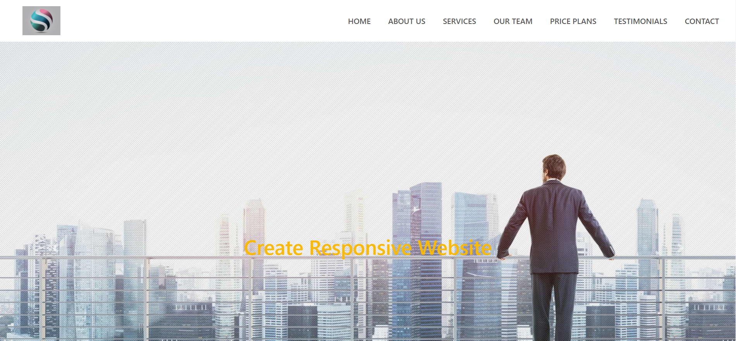

|  |
| --- |
| fig1: Home Screen |

Home Screen provides a quick overview of contents in our profession website.

*Home * Price plans

*About Us * Testimonials

*Services * Contact

*Our team

What’s new…?

I made my home-screen responsible as it can adjust itself according to screen-size…

I provided amazing hover effects and sliding scree-backgrounds with a small message of services provided. And a sticky NAVBAR.

What changes when scree is minimized…?

* NAVBAR turned to an Icon from horizontal.
* Sliding background fits to screen-size.

**Section2: ABOUT US**

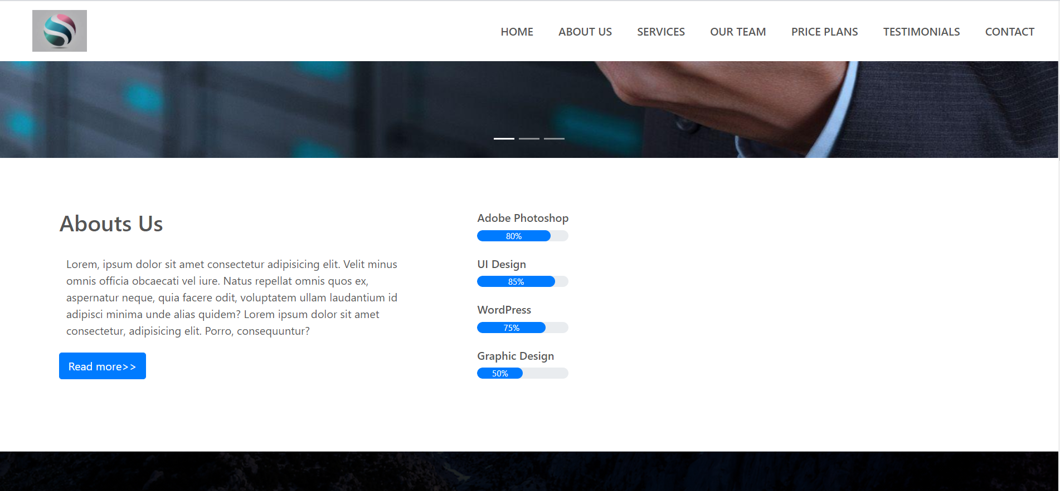

|  |
| --- |
| **fig3. About-Us Screen** |

**P**rovides description about what we are and small description about our team, our services and many more…

What’s new?

**Task-bar** gives the status about how much we developed in our field.

i.e., Adobe photoshop, UI design, WordPress and Graphic Design status…

A **read-more** button to know us about more.

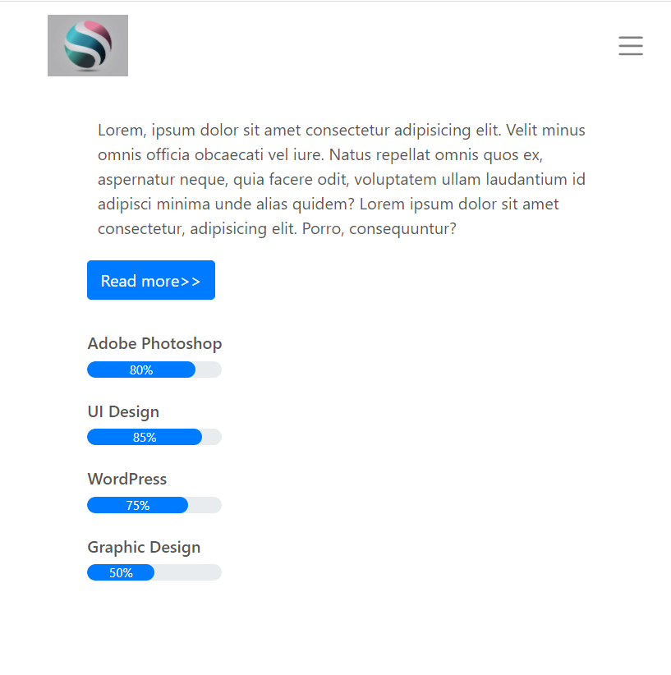

|  |
| --- |
| **fig4.Resoncible About screen with task-bar** |

**Section3: SERVICES**

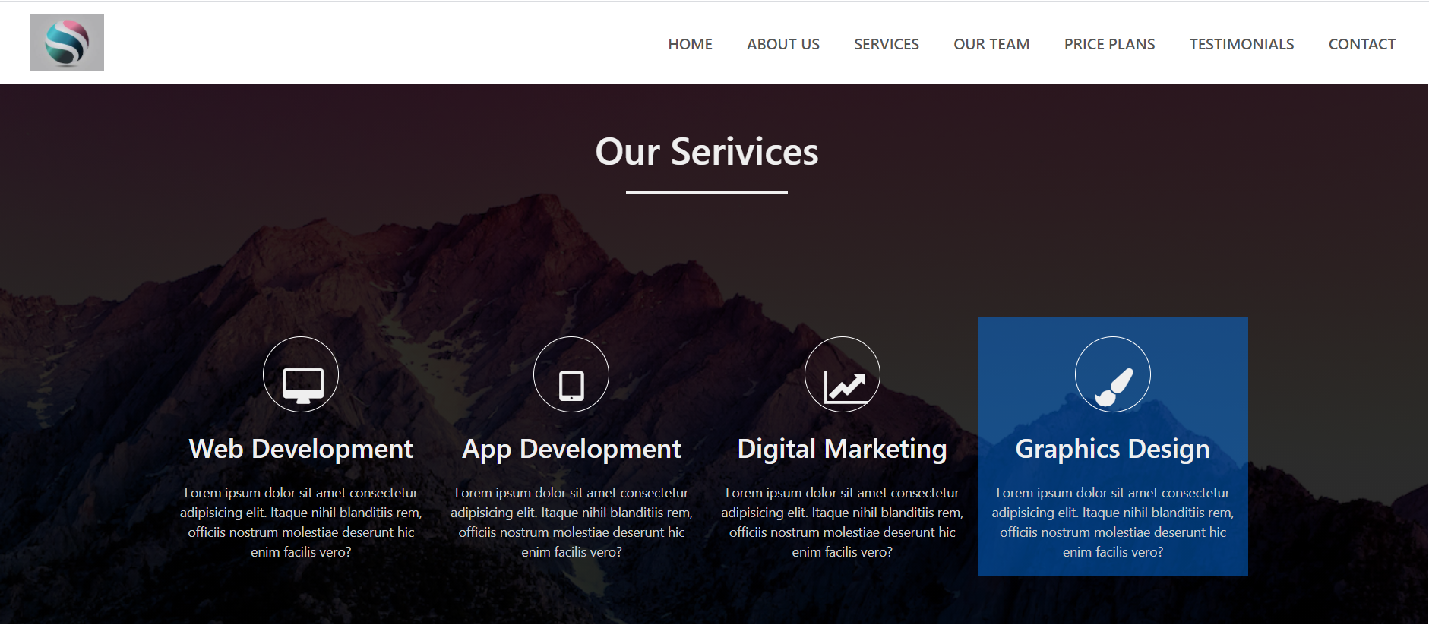

|  |
| --- |
| **Fig5: Services screen with special hover effect** |

**Website** providing 4 different services namely: Web Development, App Development, Digital Marketing, Graphics Design with small description about what course would be.

What’s new?

Special hover effect and amazing icons which are hired from “font awesome icons” and “font awesome CDN” Google websites.

And alignments and made it responsible by **Bootstrap** classes.

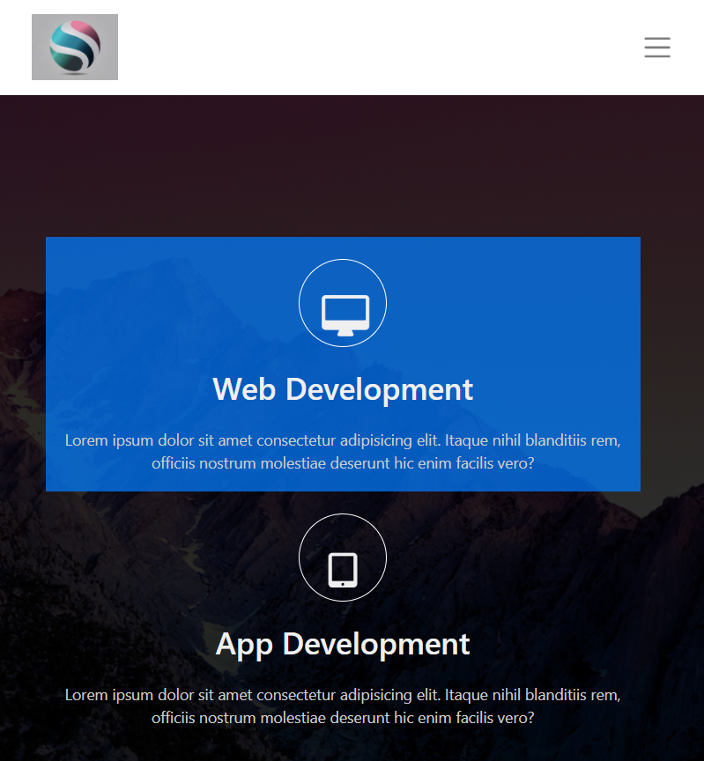

|  |
| --- |
| **fig6.Responisible service screen** |

**Section4: OUR TEAM**

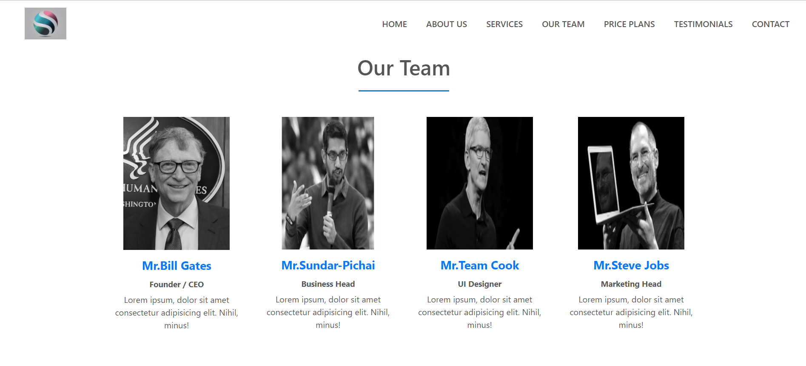

|  |
| --- |
| **fig7.Our team screen** |

**It** gives description of members of our team. Here by we provided our team member social media accounts so user/learner can contact or follow them.

What’s new…?

Special hover effect which intern changes the color of photograph and display social media account icon, which are taken by “font awesome icons”.

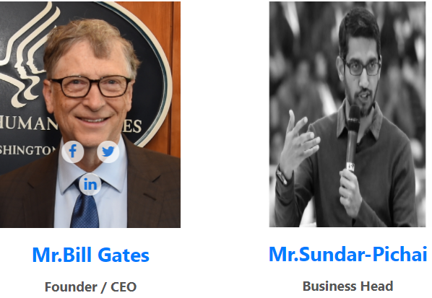

|  |
| --- |
| **fig8.OurTeam screen with hover effect** |

I used filter here in the beginning to make photograph slightly black n white and there by when user hover on its user can see the original color with social media icons.

**Section5: PRIZE PLANS**

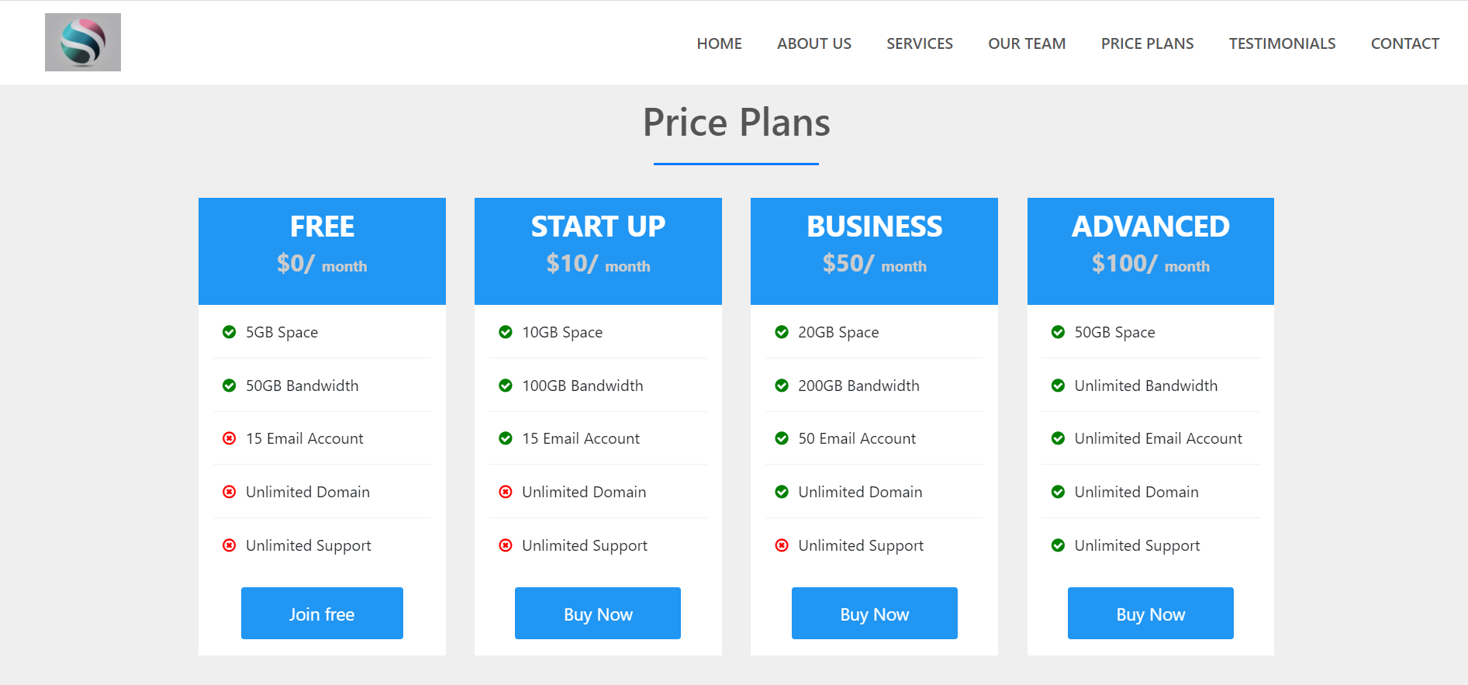

|  |
| --- |
| **fig9: Price Plan Screen** |

Prize plan screen is full of packages, so that the user can trial/buy the packages according to their need.

**I**cons used here are taken from the “font awesome icons”.

Packages available with their features are:

|  |  |  |  |
| --- | --- | --- | --- |
| Free  $0/month | Start Up $10/month | Business  $50/month | Advance  $100/month |
| ✓5GB Space,  50GB Bandwidth | ✓10GB Space,  100GB Bandwidth | ✓20GB Space,  200GB Bandwidth | ✓50GB Space,  Unlimited Bandwidth |
| ✗15 Email Account | ✓15 Email Account | ✓50 Email Account | ✓Unlimited Email Account |
| ✗Unlimited Domain | ✗Unlimited Domain | ✓Unlimited Domain | ✓Unlimited Domain |
| ✗Unlimited Support | ✗Unlimited Support | ✗Unlimited Support | ✓Unlimited Support |

**Section6: TESTIMONIALS**

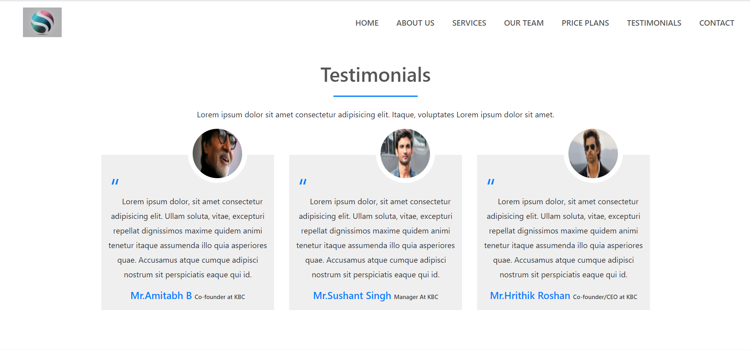

|  |
| --- |
| **fig10: Testimonials Screen** |

**T**estimonials section contains details about testimonials (a formal statement testifying to someone's character and qualifications) who already taken benefits from our website …

What’s new…?

Here in CSS I computed the ratio of photograph and I used special icons from the “font awesome icons”.

**Section7: CONTACT**

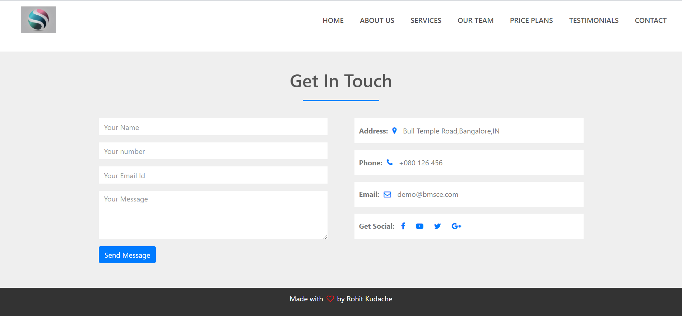

|  |
| --- |
| **fig11.Contact Screen** |

**C**ontact Section is an interface between user and our team. Basically, contact section takes Username, User number, User Email Id as an input and one message box by which we can take feedback from user excel.

What’s New…?

Here I referred from “Font-Awesome Icon” to set-up special icons in their respective position.

I given my business address along with user input to make communication flexible.

Additional:

**Footer**: Footer gives the professional feeling to the user while working with our website…

At end I used special Heart Icon to beautify my footer sentence. And icon is referred from “font awesome icons”.



|  |
| --- |
| **fig12: Footer** |

**Validation and Data management:**

1. For validation JavaScript has been used in website for smoother scroll effect. And intern sections are linked to NAVBAR.
2. Also, for the storage of the registered accounts XAMPP server will be used, which will make us linked to the html pages using php.